**TomTom Spark Cardio**

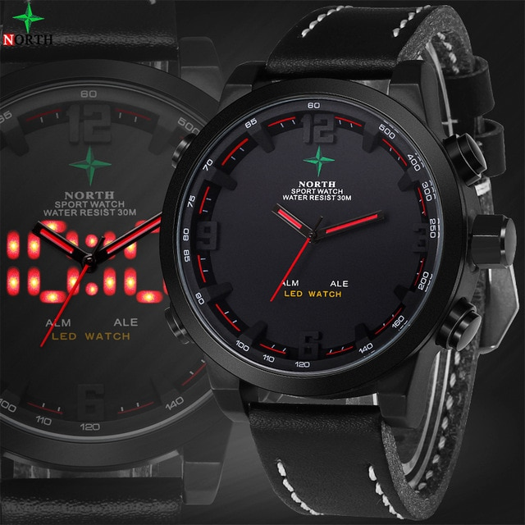

**Price:**

**Rs:6,000**